INSA Rennes – secretariat-masters@listes.insa-rennes.fr - Academic year 2026-2027


20, av. des Buttes de Coësmes – CS70839 – 35708 RENNES Cedex 7
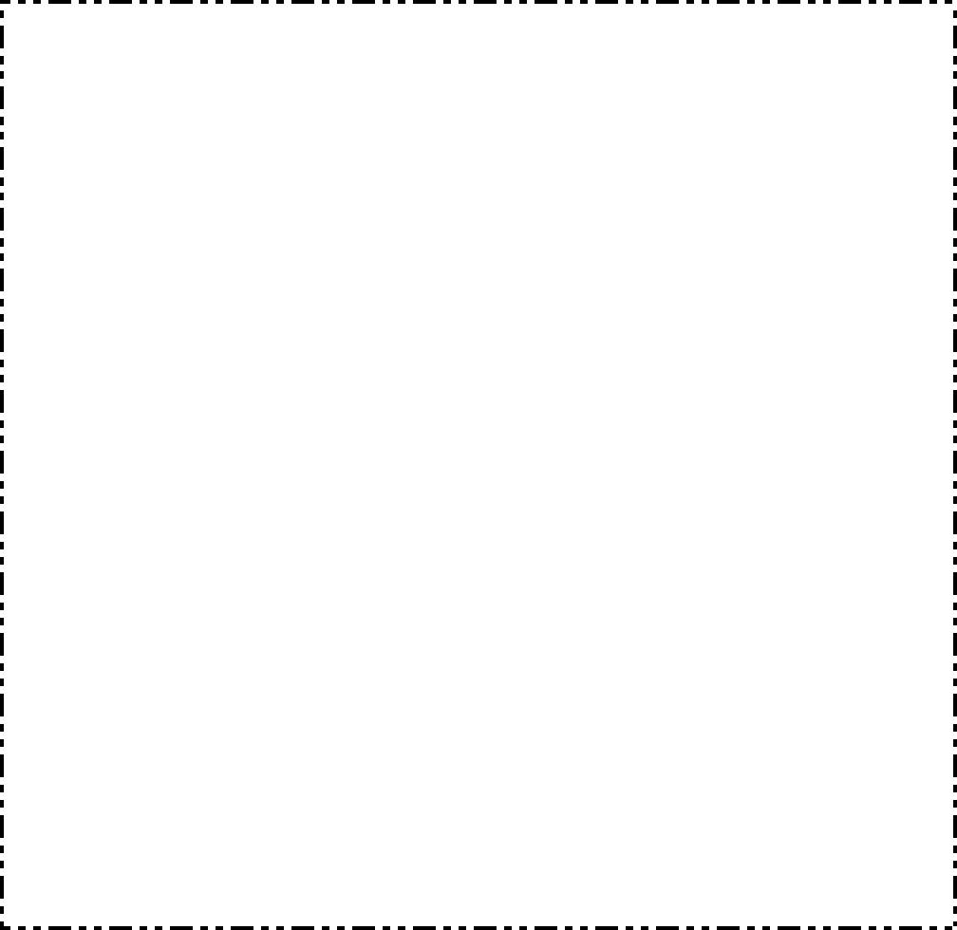

Photo
(à coller)

Frame 1 | APPLICATION FORM - MASTER
Master «Science, Technology and Health» - 2nd year
– Mention in Fundamental Physics and Applications - Course: Photonics -
ApplSpécialité : Photonique

Selected M2 option: A – Optical communications (French) Choix n° …
(indicated your choice B – Optical nanotechnologies (French) Choix n°… by order of preference) C – Imaging for health and environmental Sciences (French) Choix n°…
D – International (English) Choix n°…

Frame2 | Civil Status
Have you been a student at the INSA in the last 5 years?
if yes, indicate the academic year / and the training followed:
N° Etudiant national: | | | | | | | | | | | | | (to complete)
Sex : Male Female
Last name: Prénom : Nom d’usage : Born on: : Dept / Country : | | | | Nationality :
Current address: Postcode: | | | | | | City : Country :
Address as of 1st July 2026: Postcode : | | | | | | City : Country :
 : / / / / Mobile : / / / /
e-mail : (very legible please) @ What is your current situation?  student   job seeker  other :
Frame 3 | Baccalaureate
Series or Nature: |__| | Mention : |__| | Obtained in: | | | | Dept/Country |__| |__|City : Name Institution :
Frame 4 | Title or Diploma possessed or prepared on which the application is based
Diploma :
Obtained in : | | |__| | Mention : |__| | Dépt/Country |__| |__| City :
Name Institution :
Frame 5 |  | Post-baccalaureate courses including interruptions
Year |  | Prepared Diploma | Establishment |  | Session |  |  | Results
Frame 6 | Professional Experience
Year | Professional Experience or Personal Acquired Experience |  |  | Employer

Frame 7 | Known foreign languages : Level (reading, speaking, writing, everyday use)
language no. 1:
language no. 2

Frame 8 | Financing

Frame 9 | Motivation of the request

LIST OF ATTACHMENTS

- 1 self-adhesive 11 x 22cm envelope with your name and address on it1

- 1 Passport photograph with surname and first name on the back and glued to the location of page 1 of the folder

- A detailed Curriculum Vitae

- Photocopies of diplomas obtained (or certificates of achievement) (*)

- Transcripts of ALL examinations taken after the baccalaureate (or equivalent) (*)
- Photocopy of the programme of the last diploma possessed or prepared (*)

(*)Unsolicited documents for engineering students at the INSA in Rennes.

- For employees: Attach a certificate of employment justifying the professional experience acquired.

- For students who have studied abroad : Attach a photocopy of the syllabus, translated into French, of the studies followed after the Baccalauréat.
- Pour les étudiants étrangers d’un pays dont le français -For foreign students from a country where French is not the official language or the language of higher education, it is compulsory to provide a certificate of knowledge of the French language.:
  - or the TCF: required level: 3 or B1 (intermediate - 400 points)..
It is organised by the Centre International d'Etudes Pédagogiques (CIEP) (Cost 60 € at your expense).
  - - either the TEF: required level: 3 (between 361 and 450 points).
It is organised by the Paris Chamber of Commerce and Industry.
  - - either the DELF: required level: A3+A4 (1st degree)

For more information on these tests, contact the French Embassy in your country or the Alliance Française (www.alliancefr.org) or Edufrance (www.edufrance.fr)..

- In the absence of this certificate, the file will not be examined.

Candidates applying via the Study in France platform must submit the INSA application form at the same time as their application. This file must be complete, signed and accompanied by all the additional documents requested.

The INSA application file must reach the Masters secretariat by 4 May 2026 at the latest, so that the commissions' replies can be returned to the candidates by 30 June 2026 at the latest.

In case of interruption of higher education studies, specify the causes as well as the activities during the period(s) of interruption(s) :
FILE TO BE RETURNED SIGNED
PREFERABLY BY ELECTRONIC MEANS TO:

masters-suivi-dossier@insa-rennes.fr

OR BY POST TO:

INSA Rennes - Secrétariat des Masters – Service Recherche
20, avenue des Buttes de Coësmes – CS 70839 – 35708 RENNES cedex 7

DEADLINE FOR RECEIPT OF APPLICATIONS: 4 may 2026
ATTENTION : take into account the time limits for mail delivery
In the event of an inaccurate declaration or incomplete file, your application or registration will be systematically rejected.

I certify on my honour that the above information is correct.
Date : Student's signature :

COMPLETE MANDATORY before sending the file:
opinion of the person responsible for the training of the last diploma held or prepared
(1st year master's degree, master's degree, engineering degree, other...)

NOTICE :

Signature and stamp :

4

OPINION OF THE PEDAGOGICAL COMMISSION

☐ - F : Favorable
☐ - D : Unfavourable:
☐ - L : Waiting on complementary list - Rank:
☐ - E : Pending; reason
☐ - I : File Incomplete ; missing piece(s)
☐ - M : Other Reason
DATE : SIGNATURE:

DECISION OF THE PRESIDENT

5

